# Software Requirements Specification

# for

# Asset Management System

Version 1.0 approved

Prepared by Pisupati VNSSK Chaitanya

Software Engineering NIIT University

09/22/2018

Table of Contents

Table of Contents ii

1. Introduction 1

1.1 Purpose 1

1.2 Document Conventions 1

1.3 Intended Audience and Reading Suggestions 1

1.4 Product Scope 1

1.5 References 1

2. Overall Description 2

2.1 Product Perspective 2

2.2 Product Functions 2

2.3 User Classes and Characteristics 2

2.4 Operating Environment 2

2.5 Design and Implementation Constraints…………………………………………………………...2

2.6 User Documentation 3

2.7 Assumptions and Dependencies 3

3. External Interface Requirements 3

3.1 User Interfaces 3

3.2 Hardware Interfaces 4

3.3 Software Interfaces 4

4. System Features 4

4.1 Create Asset 4

4.2 Add Asset 5

4.3 Add Multiple Asset 6

4.4 View Asset Status 6

4.5 View Assets 7

4.6 View Asset Location 8

4.7 View Shifting History 8

4.8 Update Asset Status 9

4.9 Update Asset Location 9

4.10 Remove Asset 10

4.11 Login……………………………………………………………………………………………..11

5. Other Nonfunctional Requirements 11

5.1 Performance Requirements 11

5.2 Safety Requirements 12

5.3 Security Requirements 12

5.4 Business Rules 12

# Introduction

## Purpose

Basically, this is an ERP based model to satisfy all the infrastructural needs of students and people residing in the university. The software requirements of this project are Java it is the base of this project, SQL this is for management and <.NET which I am looking in to it.

## Document Conventions

The Conventions of this document are Starting page of this document (Arial, Size-32), Introduction, (Arial, Size-14) Table of contents, Side headings (Times, Size-14) and the information given inside the headings like text body (Times, Size-12).

## Intended Audience and Reading Suggestions

This document is for prof. Amit Kumar our faculty for Software Engineering course and for the admin members of our University. Presently this will be shown to professor later this will be shown to the admin members by combining all our group members document into one.

## Product Scope

We are designing a hostel utility check system that will the medium through which infrastructural needs of all students and staff residing in the university hostel will be recorded, checked and answered.

## References

SRS document link from Moodle.

# Overall Description

## Product Perspective

This is a self-contained product to digitalis the data that we are having in bundle of books as it is a time taking process to check whether all the requirements of a student are present and making a note, rather it would be better to make it digitalis as the data will also be secured.

## Product Functions

Front End:

1. Home
2. Check (At Arrival, At Departure)
3. Defaulter
4. Feed (Issued, Answered)
5. Authority Action
6. Help

## User Classes and Characteristics

This can be used by the users like students where they can check whether the specific requirement was checked or not. Any changes can be made by the admins.

## Operating Environment

Mobiles, Laptops and computers

## Design and Implementation Constraints

Back End

1. Importing from ERP (Complaint list, Defaulter List, Authority Action

list, Check list)

2. Information’s of Actions

3. ERP Ticket Status

4. University UID and Related Information of Staff and Students

## User Documentation

We will upload a Document manual in current ERP and there is a help option for any guidance.

**2.7 Assumptions and Dependencies**

This software can give you the correct results if the staff who is using this software should update the asset details correctly whenever it was changed.

**3. External Interface Requirements**

**3.1 User Interfaces**

The user interface will be consisting firstly of, a login page where the users will be logging in with a UID and the features respective to their authority, that is, in ascending order Staff<Audit Manager<Admin Head, will be given access to. On login page there will be a logo which will be devised for our initiative, a link leading to a help page which will be including troubleshooting and FAQ related resources and a forgot password/reset password link.

**Inside login page:**

a) **Admin Head**

1. Creating an Asset

2. Adding an Asset

3. Adding Multiple Assets

4. Viewing Asset Status

5. Updating Asset Status

**b) Audit Manager**

1. Viewing Asset Shifting History

2. Viewing Assets

**c) Staff**

1. Updating Asset Status

2. Viewing Asset Location

**3.2 Hardware Interfaces**

1. 32-bit or 64-bit Operating System

2. 2 GB RAM or more

**3.3 Software Interfaces**

1. JRE

2. MySQL (RDBMS)

**4. System Features**

**4.1 Create Asset**

**4.1.1 Description and Priority:** Admin can create a new asset that are not defined before.

**4.1.2 Stimulus/Response Sequence**: After logging into the portal admin has to click the create asset button and should give the name of an asset and then should click button create

**4.1.3 Functional Requirements:** This function is required to check whether the asset is already present or not. If it was present then no need to create the asset. User has to login to access this feature.

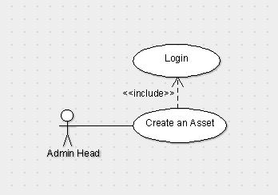

**4.2 Add Asset**

**4.2.1 Description and Priority:** Admin can add pre-defined asset and this

Will also generate unique id to the asset and by default location will be the reception. Only admin can do this function.

**4.2.2 Stimulus/Response Sequence:** Click the add asset button and then drop-down menu option appears select an asset and then click add.

**4.2.3 Functional Requirements:** This function is required to add to the particular asset we should not add the number of a particular asset to others because it leads to the difference in the number.

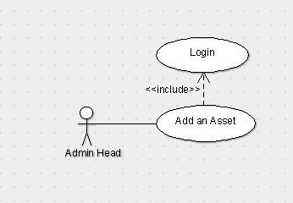

**4.3 Add Multiple Asset**

**4.3.1 Description and Priority:** It is the extension of the add Asset feature. By this admin will able to add multiple assets of same type at a time.

**4.3.2 Stimulus/Response Sequence:** Click Add multiple asset and then select the asset type and then select the number of assets you want to add then click add.

**4.3.3 Functional Requirements:** This function is required for adding number of multiple assets of a particular one. (For example, if we are having 60 chairs and 20 tables we can add all 60 chairs by giving them id at a time.)

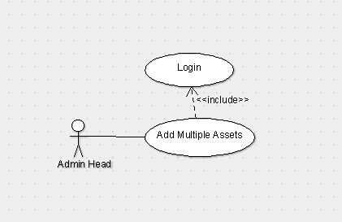

**4.4 View Asset Status**

**4.4.1 Description and Priority:** Admin can see the status of any particular asset i.e. whether it is damaged, working, repairing and cannot be repaired etc.

**4.4.2 Stimulus/Response Sequence:** Click Asset Status and then select the type of asset and then enter the respective unique id that is related to that asset and then click show Status.

**4.4.3 Functional Requirements:** This function is required to see the status of a particular asset of a particular type. (For example, if there is an asset with id Table_23 we can see the status of that particular one whether it is damaged, working, repairing and cannot be repaired etc.)

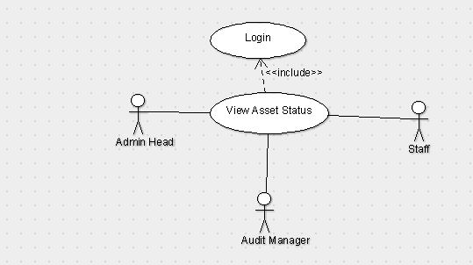

**4.5 View Asset**

**4.5.1 Description and Priority:** Admin can see the location, status, shift history etc.

**4.5.2 Stimulus/Response Sequence:** Click View Assets and then search for particular id of a particular asset type and then we can see its status, location, shift history.

**4.5.3 Functional Requirements:** This function is required for checking purpose or to just for knowing the existence of an asset (For example, if we are having an asset with Id mirror_107 by searching that we can get its location-UG-2 3306, status – working, shift history – reception->store room of UG->UG-2 3306.)

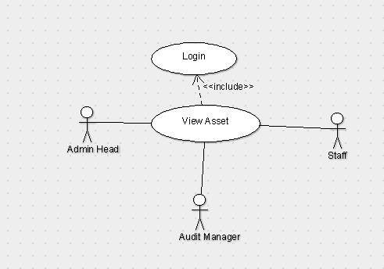

**4.6 View Asset Location**

**4.6.1 Description and Priority:** Admin can see the location of the particular asset.

**4.6.2 Stimulus/Response Sequence:** Click asset location and then enter the unique id of an asset then click show.

**4.6.3 Functional Requirements:** This function is required to check the asset Id is exists.

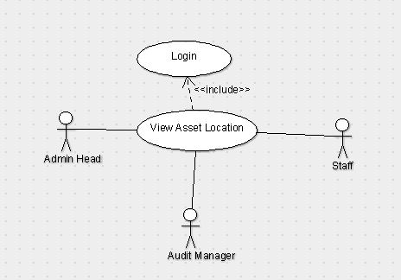

**4.7 View Shifting History**

**4.7.1 Description and Priority:** Admin can see the location history of the asset from the time that it has been created.

**4.7.2 Stimulus/Response Sequence:** Click on Shifting History and then give the unique id of the asset then click show.

**4.7.3 Functional Requirements:** This Function is required to check the asset history that from where the particular asset has been shifted (For example reception->Store room.)

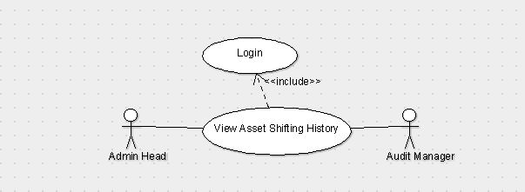

**4.8 Update Asset Status**

**4.8.1 Description and Priority:** Staff can update the status of the asset whether is it working, damaged or can’t be repaired.

**4.8.2 Stimulus/Response Sequences:** Any staff he/she having credentials will login to the page and then click on Update asset status in which we have to search for the asset with its id and then change the status of the asset to either working, damaged or can’t be repaired.

**4.8.3 Functional Requirements:** This function is required for updating the status if there is any problem with the asset otherwise the data will be corrupted if we don’t change the status. (For example, if there is a product which was damaged in the past and it was repaired. Then the change of status will be working->damaged->repaired->working.)

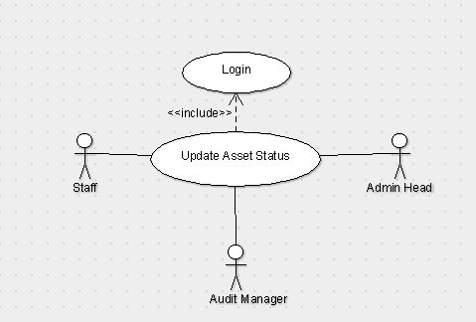

**4.9 Update Asset Location**

**4.9.1 Description and Priority:** Staff can update the location of the asset as of where the asset is present at which place.

**4.9.2 Stimulus/Response Sequences:** After staff login page we have to click on update location in which we have to search for the asset with its id by changing its room number and its location.

**4.9.3 Functional Requirements:** This function is required for updating the location of the asset if we don’t update the place then there will be a mismatch or missing of the asset and which it will be difficult to identify. (For example, if the asset is present in UG-2, 1301 and the location is changed to UG-1, 3307 then we have to update the location.)



**4.10 Remove Asset**

**4.10.1 Description and Priority:** Audit can remove any asset by checking its condition. After updating status of the asset audit can check the assets which can’t be repaired and he can remove those assets.

**4.10.2 Stimulus/Response Sequences:** After audit login page we have to click on the remove asset and enter asset Id and remove them.

**4.10.3 Functional Requirements:** Here for data purification we are removing the assets and storing them separately as they are removed. (For example, we can remove the asset by seeing the status of it’s if the status is can’t be repaired then we can remove it.)

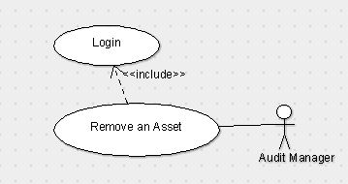

**Use Case Diagram**

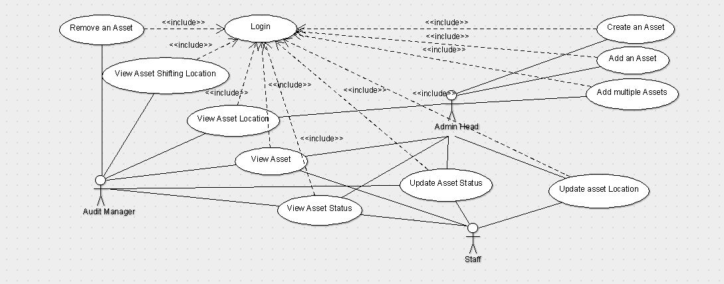

**5. Other Non-functional Requirements**

5.1 Performance Requirements

Internet Speed should be good for speed response. No one can login at two or more places at a time. 20-30 people can login at a time.

**5.2 Safety Requirements**

Staff who is using the software may change location, status wrong so there will be an Audit login in that Audit manager will be able to check the transaction histories of everything. So, it’s the responsibility of the Audit manager to take care of such wrong transactions.

**5.3 Security Requirements**

User will be provided username and password by those credentials they can login to the software and can access whatever he/she wants. We are also providing separate login for separate class of users for example admin will have a separate login and staff will have a separate login.

**5.4 Business Rules**

Create and Add Asset can only be done by Admin and they can check the asset shifting history, status, location of the particular asset. Audit has the access to removing Asset, view Asset and can check the shifting history of the assets. Staff can only update and view asset location and status. As there is some private information about assets so we are giving different logins to different type of users.